 | COMSATS University Islamabad, Attock Campus  Lab Terminal Examinations (Spring 2024)

 |  | Department of: |  | Computer Science
Class/Program: |  | BS(CS)-7th |  | Date: | 31/05/ 2024 (1:30 - 4:30)
Subject: | Compiler construction Lab EXAM |  |  | Instructor: |  | Bilal Haider
Total Time Allowed: |  |  | 3Hrs | Maximum Marks: |  |  |  | 50
Student Name: |  | SYED ABDULLAH  MUHAMMAD HASEEB |  | Registration #: |  |  | Sp21-BCS-037  SP21-BCS-020

To submit create a world file titled csc441-sp23-lab terminal-your complete registration number.docx.
Each question has 10 marks, please make a word file for answer of question 1 and 2, add screen shots of your input and output of question 3 and 4 in the same world document. Upload your code for project, question3 and question on google drive and paste it at the end of the word document
Viva will have 10 marks you can give viva until 27th of june 2023.
Question 1
Write an introduction of your compiler construction project
INTRODUCTION:
We have build a self-compiling mini-compiler for C++. C++ is a general purpose programming language and widely used now a days for competitive programming. It has imperative, object-oriented and generic programming features. The two main constructs that we have focused on while building this compiler are ‘while’ and ‘for’ loops. The compiler also identifies arithmetic, boolean and logical operations. The expected outcome of this project is generate a Symbol Table, an Abstract Syntax Tree and Intermediate Three-Address code along with optimization.

Question 2
Give a sample input and output for your compiler construction project
INPUT:
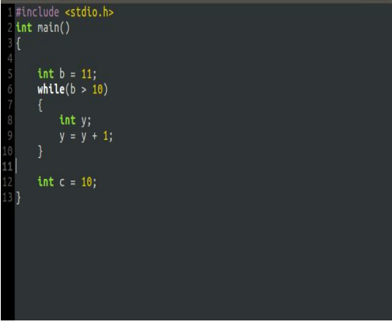

OUTPUT:
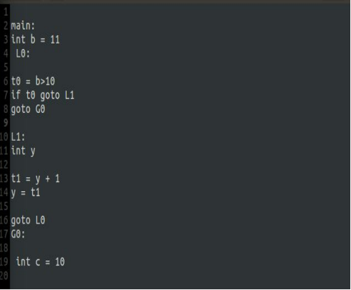

SYMBOL TABLE
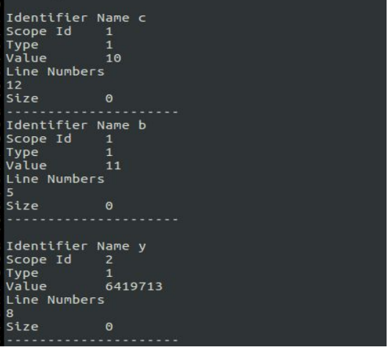

ABSTRACT SYNTAX TREE
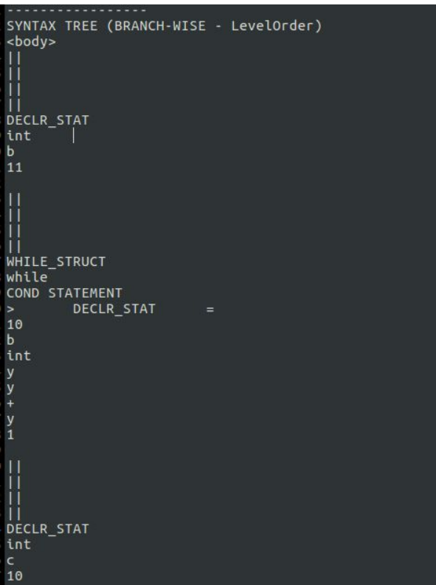

INTERMEDIATE CODE GENERATION
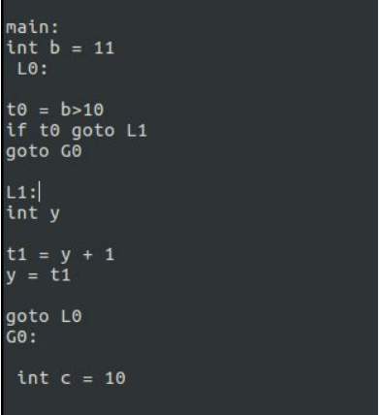

Question 3

Create and implement RE and DFAs for the form below
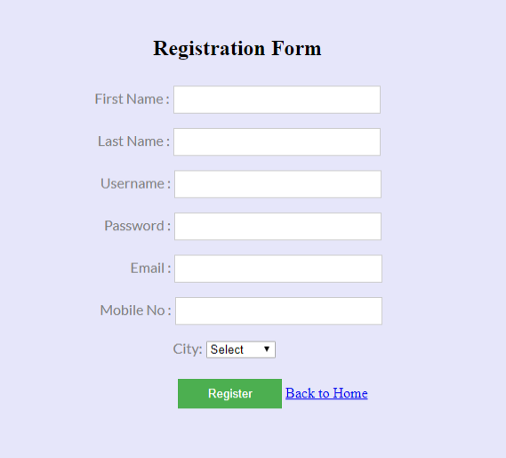
You must use Regex to validate data.
ANSWER:
import re

# Regular Expressions
regexes = {
"first_name": re.compile(r"^[A-Za-z]+$"),
"last_name": re.compile(r"^[A-Za-z]+$"),
"username": re.compile(r"^[A-Za-z0-9_]{3,16}$"),
"password": re.compile(r"^(?=.[A-Za-z])(?=.\d)(?=.[@$!%?&])[A-Za-z\d@$!%*?&]{8,}$"),
"email": re.compile(r"^[a-zA-Z0-9._%+-]+@[a-zA-Z0-9.-]+\.[a-zA-Z]{2,}$"),
"mobile_no": re.compile(r"^\d{10}$")
}

# DFA Simulation Function
def validate_input(field, value):
if field in regexes:
return bool(regexes[field].match(value))
return False

# Test Cases
test_data = {
"first_name": "John",
"last_name": "Doe",
"username": "john_doe_123",
"password": "Passw0rd!",
"email": "john.doe@example.com",
"mobile_no": "1234567890"
}

# Validation
validation_results = {field: validate_input(field, value) for field, value in test_data.items()}
print(validation_results)

Question 4:
Write a program which generates symbol table for the code you submitted in question 3

class SymbolTable:
def _init_(self):
self.table = {}

def add(self, name, type, value=None):
self.table[name] = {"type": type, "value": value}

def get(self, name):
return self.table.get(name, None)

def _str_(self):
result = "Symbol Table:\n"
result += "Name\t\tType\t\tValue\n"
result += "-"*40 + "\n"
for name, info in self.table.items():
result += f"{name}\t\t{info['type']}\t\t{info['value']}\n"
return result

# Creating the symbol table
symbol_table = SymbolTable()

# Adding variables to the symbol table
symbol_table.add("regexes", "dictionary", {
"first_name": r"^[A-Za-z]+$",
"last_name": r"^[A-Za-z]+$",
"username": r"^[A-Za-z0-9_]{3,16}$",
"password": r"^(?=.[A-Za-z])(?=.\d)(?=.[@$!%?&])[A-Za-z\d@$!%*?&]{8,}$",
"email": r"^[a-zA-Z0-9._%+-]+@[a-zA-Z0-9.-]+\.[a-zA-Z]{2,}$",
"mobile_no": r"^\d{10}$"
})
symbol_table.add("validate_input", "function", "validates input based on regexes")
symbol_table.add("test_data", "dictionary", {
"first_name": "John",
"last_name": "Doe",
"username": "john_doe_123",
"password": "Passw0rd!",
"email": "john.doe@example.com",
"mobile_no": "1234567890"
})
symbol_table.add("validation_results", "dictionary", None)

regexes = {
"first_name": re.compile(r"^[A-Za-z]+$"),
"last_name": re.compile(r"^[A-Za-z]+$"),
"username": re.compile(r"^[A-Za-z0-9_]{3,16}$"),
"password": re.compile(r"^(?=.[A-Za-z])(?=.\d)(?=.[@$!%?&])[A-Za-z\d@$!%*?&]{8,}$"),
"email": re.compile(r"^[a-zA-Z0-9._%+-]+@[a-zA-Z0-9.-]+\.[a-zA-Z]{2,}$"),
"mobile_no": re.compile(r"^\d{10}$")
}
# Adding regexes to the symbol table
for key in regexes:
symbol_table.add(f"regex_{key}", "regex", regexes[key].pattern)

# Printing the symbol table
print(symbol_table)

